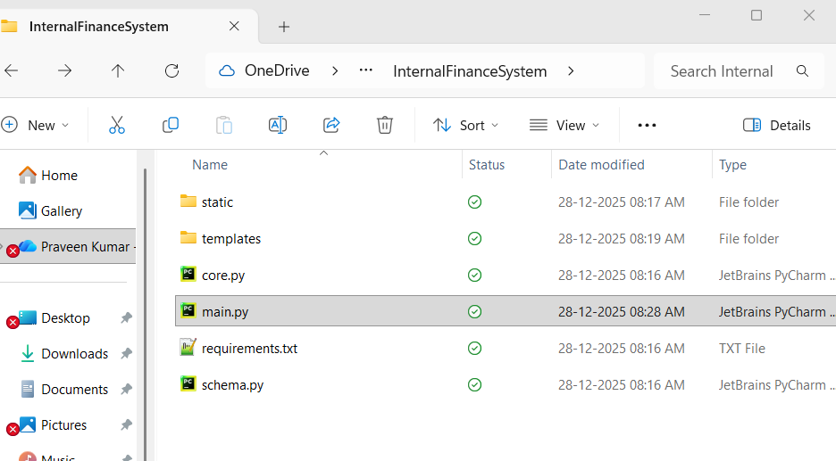

Setup the above folder structure
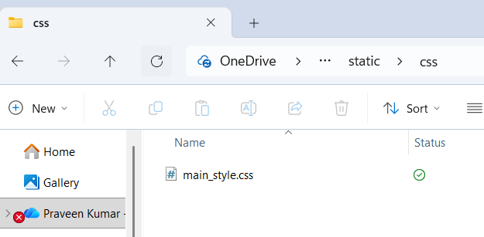

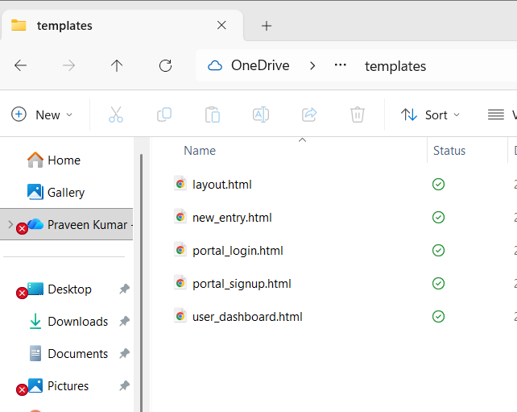

Main.py contents as below:

from flask import Flask

app = Flask(__name__)

@app.route("/")
def home():
print("User accessed the homepage")
return "Internal Finance System is Live!"

if __name__ == "__main__":
app.run(debug=True)

=============================
from flask import Flask
- Why: Python is a general language. It doesn't know how to be a website by default. We are "importing" a tool called Flask which gives Python the ability to understand URLs and web pages.
app = Flask(__name__)
- Why: This creates the actual application object. __name__ is a special built-in variable that tells Flask: "Look for resources (like your templates and static folders) right here in this current folder."
@app.route("/")
- Why: This is an Address. The / symbol represents the "home" page (like just google.com with nothing after it). We are telling Python: "If someone visits the main address of this app, do the function immediately below this line."
def home():
- Why: This defines the function (the task). The task is simply to print a message to your console (for you) and return a message to the browser (for the user).
if __name__ == "__main__":
- Why: This is a safety guard. It ensures the web server only starts if you run this specific file ( python main.py). If you later imported main.py into another file just to test a function, this line prevents the server from accidentally starting up.
app.run(debug=True)
- Why: This starts the local web server on your computer. debug=True is critical for learning—it means if you make a mistake, the web page will show you the exact error code instead of just crashing silently.
Run 1: python main.py
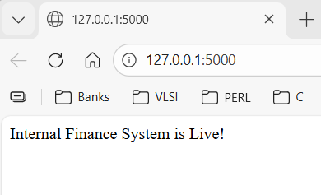
Right now, your main.py sends back a simple text sentence ("Internal Finance System is Live!"). But real apps need buttons, colors, and structure. We don't write that in Python; we write that in HTML.
We need to connect your main.py to that empty templates folder you created earlier.
Action 1: Create the Interface
Go into your templates folder and create a new file named index.html. Paste this code inside it:
<!DOCTYPE html>
<html>
<body>
<h1>Internal Finance Portal</h1>
<p>System Status: <b style="color:green">Active</b></p>
</body>
</html>

• Why index.html?: In the web world, index is the standard name for the "default" page or homepage.
• Why <b> and <h1>?: These are HTML tags. h1 makes the text big (Heading 1). b makes it bold.
Action 2: Update the Logic
Now we need to tell Python to stop sending plain text and start sending this file instead.
Go back to main.py and modify it to look exactly like this (pay attention to the 2 changes marked):
from flask import Flask, render_template # <--- CHANGE 1: Added render_template

app = Flask(__name__)

@app.route("/")
def home():
print("User is asking for the dashboard...")
return render_template("index.html") # <--- CHANGE 2: swapped the string for the file

if __name__ == "__main__":
app.run(debug=True)

The "Connecting the Dots" Explanation
- from flask import ... render_template
  - Why: We imported a new tool. render_template is a special function Flask provides that says: "Go look inside the templates folder, find the file I named, and send it to the user."
  - The Dot Connected: This links your Python code (main.py) to your Design folder (templates). Without this, Python cannot see inside that folder.
- return render_template("index.html")
  - Why: Previously, we returned a "String" (text). Now we return a "File". Python processes the HTML file and sends the result to the browser.
Action:
- Save both files (index.html and main.py).
- Your terminal might automatically reload (you'll see "Detected change in... Reloading"). If not, click in the terminal, press Ctrl+C to stop, and run python main.py again.
- Go to your browser and refresh the page at http://127.0.0.1:5000.
Reply: Tell me if you see the big bold text "Internal Finance Portal" in your browser. Then we will add a variable to make it dynamic.

Now, let's make it a "Dynamic Application." This is the core of web development: Python calculates data, and HTML displays it.
Step 4: Sending Data from Python to HTML
We are going to make the page greet a specific user, but the name will come from your Python code, not typed into the HTML file.
Action 1: Update main.py (The Sender)
Modify your home() function to create a variable and pass it to the template.
@app.route("/")
def home():
current_user = "Admin User" # <--- created a variable
print(f"Loading dashboard for: {current_user}")

# We pass the variable into the template like shipping a package
return render_template("index.html", user_name=current_user)

Action 2: Update templates/index.html (The Receiver)
Modify your HTML to "catch" that variable and display it. We use special double curly braces {{ }} for this.
<!DOCTYPE html>
<html>
<body>
<h1>Internal Finance Portal</h1>
<p>Welcome back, <b>{{ user_name }}</b></p>
</body>
</html>

The "Connecting the Dots" Explanation
- return render_template(..., user_name=current_user)
  - The Dot Connected: This is the bridge. You are saying: "Mr. Template, I am sending you a package. inside your HTML code, you will know it as user_name, but here in Python, the value comes from current_user."
  - Why: This allows you to change the name in one place (Python) and have it update on the website automatically. If you later connect a database, Python will pull the real name from the database and just slot it into current_user.
- {{ user_name }}
  - Why: HTML is dumb; it only understands text. These curly braces are a signal to Jinja2 (the engine Flask uses). It tells Flask: "Don't print these braces. Instead, look for a variable named user_name that Python sent over, and put its value right here."
Action:
- Save both files.
- Refresh your browser.
- Experiment: In main.py, change current_user = "Admin User" to your own name (e.g., current_user = "Praveen"), save, and refresh.

Action 1: Add content to main_style.css
Open your existing empty file static/css/main_style.css and paste the style rules there:
CSS
body {
background-color: #f4f4f9; /* Light Grey-Blue background */
font-family: sans-serif; /* Cleaner, modern text font */
text-align: center; /* Center everything */
}

h1 {
color: #2c3e50; /* Dark Blue text for the header */
}
Now update the index.html to with below content:
Action 2: Update the Link in index.html
Because your file is inside a subfolder (css), we must tell Python to look deeper.
Open templates/index.html and use this specific link tag. Notice the change in filename.
HTML
<!DOCTYPE html>
<html>
<head>
<link rel="stylesheet" href="{{ url_for('static', filename='css/main_style.css') }}">
</head>
<body>
<h1>Internal Finance Portal</h1>
<p>Welcome back, <b>{{ user_name }}</b></p>
</body>
</html>

Now, let's look at core.py.
Step 6: Separating the "Brain" from the "Face"
Right now, if we want to calculate complex finance math, we could write it in main.py. But main.py is like a Receptionist—its job is just to greet visitors (URLs) and point them to the right room. It shouldn't be doing the heavy math.
We will move the "Thinking" logic to core.py.

Action 1: Create the Logic in core.py
Open core.py (which is currently empty) and paste this code:
Python
def calculate_savings(monthly_amount):
# We assume a simple calculation: Monthly * 12 months
annual_total = monthly_amount * 12
return annual_total

Why: This is a pure function. It takes a number, does math, and gives it back. It doesn't know about websites, HTML, or Flask. It just does math. This makes it easy to test later without running the whole server.

Action 2: Connect core.py to main.py
We need to tell the Receptionist (main.py) that they have a Specialist (core.py) available to do the math.
Modify main.py to look like this (pay attention to the new import line and the new variable):
from flask import Flask, render_template
from core import calculate_savings # <--- NEW: Importing your tool from core.py

app = Flask(__name__)

@app.route("/")
def home():
current_user = "Praveen"

# We use the function from core.py here
my_savings = 5000
estimated_annual = calculate_savings(my_savings)

# We pass both the name AND the calculated money to the HTML
return render_template("index.html", user_name=current_user, money=estimated_annual)

if __name__ == "__main__":
app.run(debug=True)

Action 3: Display the Result in HTML
Now that main.py has calculated the money and sent it in the package, we need to open the box in HTML.

Open templates/index.html and add a line to show the money:

<!DOCTYPE html>
<html>
<head>
<link rel="stylesheet" href="{{ url_for('static', filename='css/main_style.css') }}">
</head>
<body>
<h1>Internal Finance Portal</h1>
<p>Welcome back, <b>{{ user_name }}</b></p>

<p>Projected Annual Savings: <b>{{ money }}</b></p>
</body>
</html>

The "Connecting the Dots" Explanation
- from core import calculate_savings:
  - The Dot Connected: You are connecting two separate Python files. main.py can now see inside core.py.
  - Why: If you have 100 different finance formulas, you don't want them cluttering up your web server file. You hide them in core.py so main.py stays clean and easy to read.
- estimated_annual = calculate_savings(my_savings):
  - Why: This is the moment the Receptionist hands the work to the Specialist. main.py hands over 5000, core.py multiplies it by 12, and hands back 60000.
- {{ money }}:
  - Why: Just like we did with the name, we use the double curly braces to display the result of that calculation.
Action:
- Save core.py, main.py, and index.html.
- Refresh your browser.

Now, let's look at core.py.
Step 6: Separating the "Brain" from the "Face"
Right now, if we want to calculate complex finance math, we could write it in main.py. But main.py is like a Receptionist—its job is just to greet visitors (URLs) and point them to the right room. It shouldn't be doing the heavy math.
We will move the "Thinking" logic to core.py.
Action 1: Create the Logic in core.py
Open core.py (which is currently empty) and paste this code:
def calculate_savings(monthly_amount):
# We assume a simple calculation: Monthly * 12 months
annual_total = monthly_amount * 12
return annual_total

Why: This is a pure function. It takes a number, does math, and gives it back. It doesn't know about websites, HTML, or Flask. It just does math. This makes it easy to test later without running the whole server.

Action 2: Connect core.py to main.py
We need to tell the Receptionist (main.py) that they have a Specialist (core.py) available to do the math.
Modify main.py to look like this (pay attention to the new import line and the new variable):

from flask import Flask, render_template
from core import calculate_savings # <--- NEW: Importing your tool from core.py

app = Flask(__name__)

@app.route("/")
def home():
current_user = "Praveen"

# We use the function from core.py here
my_savings = 5000
estimated_annual = calculate_savings(my_savings)

# We pass both the name AND the calculated money to the HTML
return render_template("index.html", user_name=current_user, money=estimated_annual)

if __name__ == "__main__":
app.run(debug=True)

Action 3: Display the Result in HTML
Now that main.py has calculated the money and sent it in the package, we need to open the box in HTML.
Open templates/index.html and add a line to show the money:
<!DOCTYPE html>
<html>
<head>
<link rel="stylesheet" href="{{ url_for('static', filename='css/main_style.css') }}">
</head>
<body>
<h1>Internal Finance Portal</h1>
<p>Welcome back, <b>{{ user_name }}</b></p>

<p>Projected Annual Savings: <b>{{ money }}</b></p>
</body>
</html>

The "Connecting the Dots" Explanation
- from core import calculate_savings:
  - The Dot Connected: You are connecting two separate Python files. main.py can now see inside core.py.
  - Why: If you have 100 different finance formulas, you don't want them cluttering up your web server file. You hide them in core.py so main.py stays clean and easy to read.
- estimated_annual = calculate_savings(my_savings):
  - Why: This is the moment the Receptionist hands the work to the Specialist. main.py hands over 5000, core.py multiplies it by 12, and hands back 60000.
- {{ money }}:
  - Why: Just like we did with the name, we use the double curly braces to display the result of that calculation.
Action:
- Save core.py, main.py, and index.html.
- Refresh your browser.
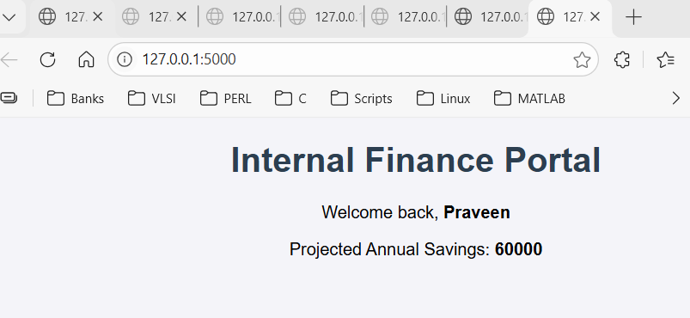

This is perfect. You have built a working MVC (Model-View-Controller) application.
- Model (core.py): Does the math.
- View (index.html): Shows the result.
- Controller (main.py): Connects them.
Now, let's fix the biggest problem: The value 5000 is "hard-coded". If the user wants to calculate for 10,000, they have to ask you to rewrite the code. That is bad.
We need to let the user type the number themselves.
Step 7: Handling User Input (The Form)
We need to create a "Mailbox" where the user can drop their number, and Python can pick it up.
Action 1: Create the Input Box in HTML
Open templates/index.html. We are going to replace the <p>Projected...</p> line with a Form.
Replace your <body> content with this:
<body>
<h1>Internal Finance Portal</h1>
<p>Welcome back, <b>{{ user_name }}</b></p>

<form method="POST">
<label>Enter Monthly Savings:</label>
<input type="number" name="savings_input" required>
<input type="submit" value="Calculate">
</form>

{% if money %}
<hr>
<h3>Result:</h3>
<p>Projected Annual Savings: <b>{{ money }}</b></p>
{% endif %}
</body>
form method="POST": This tells the browser: "When the user clicks the button, pack up the data and POST (send) it to the server."
name="savings_input": This is the label on the package. Python will look for this specific name to find the value.
{% if money %}: This is a logic check. It says "Only show the result section if Python actually sent us money data."

Action 2: Catch the Data in Python
Now we need to teach main.py how to catch that package.
Open main.py and update it carefully:

# CHANGE 1: Import 'request'
from flask import Flask, render_template, request
from core import calculate_savings

app = Flask(__name__)

# CHANGE 2: Allow both GET (viewing) and POST (sending data)
@app.route("/", methods=["GET", "POST"])
def home():
current_user = "Praveen"
estimated_annual = None # Start with nothing

# CHANGE 3: Check if the user just hit the button
if request.method == "POST":
# We grab the text from the box named "savings_input"
user_input = int(request.form["savings_input"])
estimated_annual = calculate_savings(user_input)

return render_template("index.html", user_name=current_user, money=estimated_annual)

if __name__ == "__main__":
app.run(debug=True)

The "Connecting the Dots" Explanation
- methods=["GET", "POST"]:
  - The Dot Connected: By default, web pages only allow GET (reading). We added POST (writing/sending). If you don't add this, you will get a "405 Method Not Allowed" error when you click the button.
- request.form["savings_input"]:
  - Why: This connects to the HTML input <input name="savings_input">.
  - Logic: Python reaches into the "form" bag, pulls out the specific item labeled savings_input, and converts it to an integer (int) so we can do math on it.
- The Flow:
  - Step A: You load the page (GET). money is None. The HTML hides the result section.
  - Step B: You type 2000 and click Calculate (POST).
  - Step C: Python catches the 2000, calculates 24000, and reloads the page.
  - Step D: Now money is 24000. The HTML sees this and reveals the result section.
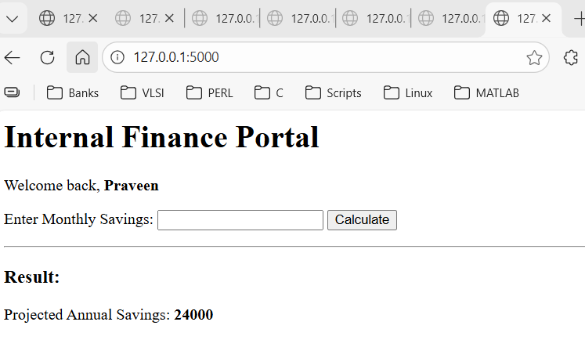
Now we face the final big concept. If you close your browser now, that data (24000) vanishes forever. We need to save it. We need a Database.
You already created schema.py for this exact purpose.

Step 8: Building the "Storage Cabinet" (Database)
A database is just a file where data lives permanently. To use it, we first have to "build the furniture"—we need to tell Python exactly what our data tables look like.
Action 1: Define the Structure
Open your empty schema.py file and paste this code:
import sqlite3

# 1. Open a connection to a file named 'finance.db'
# (If it doesn't exist, Python creates it for us)
connection = sqlite3.connect("finance.db")

# 2. Create a 'Cursor'
# Think of this as the "robot arm" that actually does work inside the database
cursor = connection.cursor()

# 3. Write instructions to build a Table
# We call this table 'users_data'
cursor.execute(
"""
CREATE TABLE IF NOT EXISTS users_data (
id INTEGER PRIMARY KEY AUTOINCREMENT,
username TEXT,
monthly_savings INTEGER,
projected_annual INTEGER
);
"""
)

# 4. Save the changes
connection.commit()

# 5. Close the connection
connection.close()

print("Database structure created successfully!")

The "Connecting the Dots" Explanation
- import sqlite3
  - Why: This is a standard Python tool. You don't need to install anything. It lets Python create and manage light-weight SQL databases (which are just files on your computer).
- connection = sqlite3.connect("finance.db")
  - The Dot Connected: This is the bridge between your Python code and the hard drive. It says, "I want to work with a file named finance.db."
- cursor.execute(...)
  - Why: This runs SQL (Structured Query Language). SQL is the language databases speak.
  - CREATE TABLE IF NOT EXISTS: This is safety code. It means "Build this table only if it's not already there. If it is there, don't delete my old data."
  - The Columns (username, monthly_savings, etc.): These are like the column headers in an Excel sheet. We are defining exactly what data fits in which slot.
- connection.commit()
  - Critical: If you forget this line, Python does the work in its head but never actually saves it to the file. commit() means "Save file."
- Right now, your website (main.py) calculates the number but throws it away immediately after showing it. We need to teach it to open the file and write the result down before it forgets.
- Step 9: Saving Data from the Website to the Database
- We are going to modify main.py to talk to finance.db.
- Action 1: Update main.py
- Open main.py and replace the code with this version. I have marked the 3 new sections you need to pay attention to.
from flask import Flask, render_template, request
from core import calculate_savings
import sqlite3 # <--- NEW SECTION 1: Import the database tool

app = Flask(__name__)

@app.route("/", methods=["GET", "POST"])
def home():
current_user = "Praveen"
estimated_annual = None

if request.method == "POST":
user_input = int(request.form["savings_input"])
estimated_annual = calculate_savings(user_input)

# <--- NEW SECTION 2: Connect to the DB
# We open the connection to the file we created in Step 8
connection = sqlite3.connect("finance.db")
cursor = connection.cursor()

# <--- NEW SECTION 3: Write the data (The "INSERT" command)
# We use '?' as placeholders for the real data
cursor.execute(
"INSERT INTO users_data (username, monthly_savings, projected_annual) VALUES (?, ?, ?)",
(current_user, user_input, estimated_annual)
)

connection.commit() # Save the changes
connection.close() # Close the file
print("Data successfully saved to finance.db!")

return render_template("index.html", user_name=current_user, money=estimated_annual)

if __name__ == "__main__":
app.run(debug=True)

The "Connecting the Dots" Explanation
- import sqlite3
  - Why: Just like in schema.py, main.py needs this tool to be able to talk to the database file.
- INSERT INTO users_data ... VALUES (?, ?, ?)
  - The Dot Connected: This is the command that puts data into the table we built in Step 8.
  - Why the ? symbols?: These are safety slots. We tell Python: "I am going to give you three pieces of data (Name, Savings, Total). Please put them safely into these three slots."
  - The Tuple (current_user, user_input, estimated_annual): This is the actual data we are handing over to fill those ? slots.
- connection.commit()
  - Why: As I mentioned before, if you don't run this line, the data is lost. It effectively hits the "Save" button on the database file.
Action:
- Save main.py.
- Important: If your previous python main.py is still running in the terminal, you must stop it first (Press Ctrl+C).
- Run python main.py again.
- Go to the browser, enter a new number (e.g., 3000), and click Calculate.
- Reply: Look at your VS Code Terminal (not the browser). Do you see the message: Data successfully saved to finance.db!?
- If yes, you have just built a "Full Stack" application: Front-end (HTML), Back-end (Python), and Database (SQLite) are all working together!
- This is a massive milestone. You have successfully built a system that remembers.
- Now for the final test. If you close your browser and open it tomorrow, you want to see that data again. Currently, the data is safe in the file, but your website isn't showing it to you yet.
- Let's create a "History" section on your page to display everything stored in finance.db.
- Step 10: Reading Data from the Database
- We need to tell main.py to Read the database every time the page loads.
- Action 1: Update main.py to Fetch Data
- We will add a "Select" query. Update your home() function in main.py to match this.
- Note: I moved the database connection outside the if block because we want to see the history always, even if we are just visiting the page (GET) and not calculating anything (POST).
@app.route("/", methods=["GET", "POST"])
def home():
current_user = "Praveen"
estimated_annual = None

# 1. Open the Connection (We do this first now)
connection = sqlite3.connect("finance.db")
cursor = connection.cursor()

# 2. If User Clicked Button: Calculate & Save
if request.method == "POST":
user_input = int(request.form["savings_input"])
estimated_annual = calculate_savings(user_input)

cursor.execute(
"INSERT INTO users_data (username, monthly_savings, projected_annual) VALUES (?, ?, ?)",
(current_user, user_input, estimated_annual)
)
connection.commit()
print("Data saved.")

# 3. ALWAYS: Fetch all past data to show history
# "SELECT *" means "Give me every column"
cursor.execute("SELECT * FROM users_data")
db_data = cursor.fetchall()

connection.close()

# 4. Send both the 'money' (current) and 'history' (past) to HTML
return render_template("index.html", user_name=current_user, money=estimated_annual, history=db_data)

Action 2: Update index.html to Display the List
We need a loop. HTML doesn't have loops, but Jinja2 (the {} tool) does.
Open templates/index.html and add this table at the bottom of your <body>, right after the Result block.
<hr>
<h3>Calculation History</h3>

<table border="1" style="width:50%; margin:auto;">
<tr>
<th>ID</th>
<th>Name</th>
<th>Monthly</th>
<th>Annual</th>
</tr>

{% for row in history %}
<tr>
<td>{{ row[0] }}</td> <td>{{ row[1] }}</td> <td>{{ row[2] }}</td> <td>{{ row[3] }}</td> </tr>
{% endfor %}

</table>

The "Connecting the Dots" Explanation
- cursor.fetchall():
  - The Dot Connected: This is the opposite of INSERT. It grabs every single row from your Excel-like database table and puts it into a Python list variable called db_data.
- {% for row in history %}:
  - Why: If you have 1 entry or 1,000 entries, this code handles it automatically. It repeats the <tr> (table row) code for every single item in the list passed from Python.
- {{ row[2] }}:
  - Why: The database returns data as a list of items: (1, "Praveen", 2000, 24000). Computers count from zero.
    - row[0] is the ID (1)
    - row[1] is the Name ("Praveen")
    - row[2] is the Savings (2000)
Action:
- Save main.py and index.html.
- Restart your server (Ctrl+C then python main.py).
- Refresh your browser.

Now for the final test. If you close your browser and open it tomorrow, you want to see that data again. Currently, the data is safe in the file, but your website isn't showing it to you yet.

Let's create a "History" section on your page to display everything stored in finance.db.

Step 10: Reading Data from the Database
We need to tell main.py to Read the database every time the page loads.

Action 1: Update main.py to Fetch Data
We will add a "Select" query. Update your home() function in main.py to match this.

Note: I moved the database connection outside the if block because we want to see the history always, even if we are just visiting the page (GET) and not calculating anything (POST).

